Name: Shivam Tiwari Roll No: 5117060

Experiment 5

**Aim:** To demonstrate and implement IAAS service using AWS (Use t2.Micro (Free tier eligible) (instance only).

**Steps:**

1. Login to AWS portal and Select EC2 service from admin console.

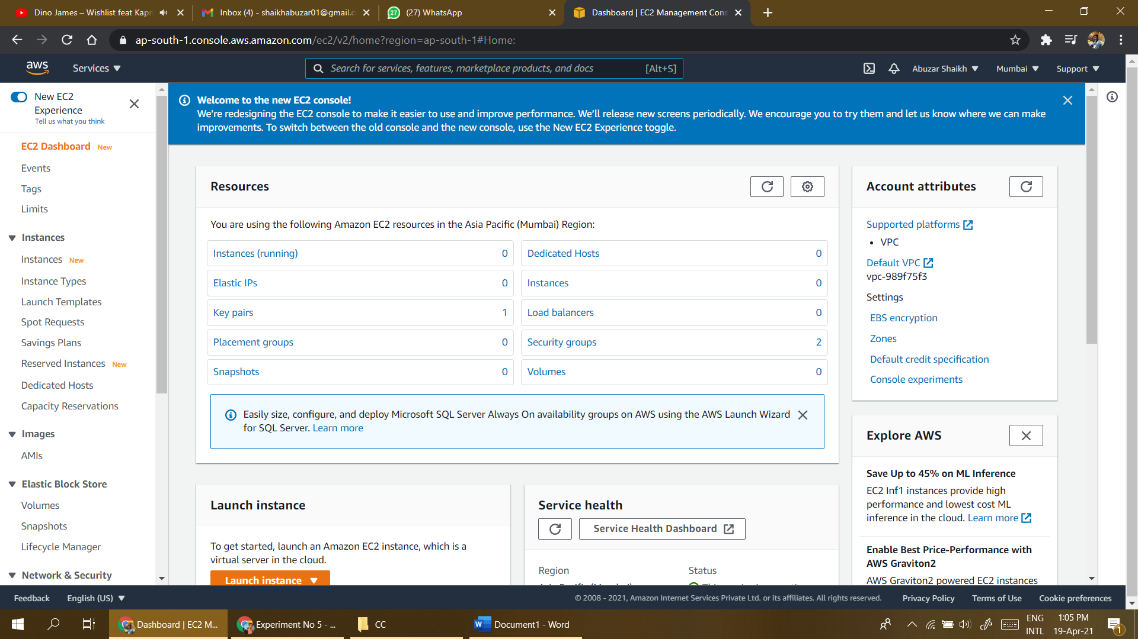

1. The EC2 resource page will appear which will show you the summary of instances. Now click on launch instance to select the VM instance type.

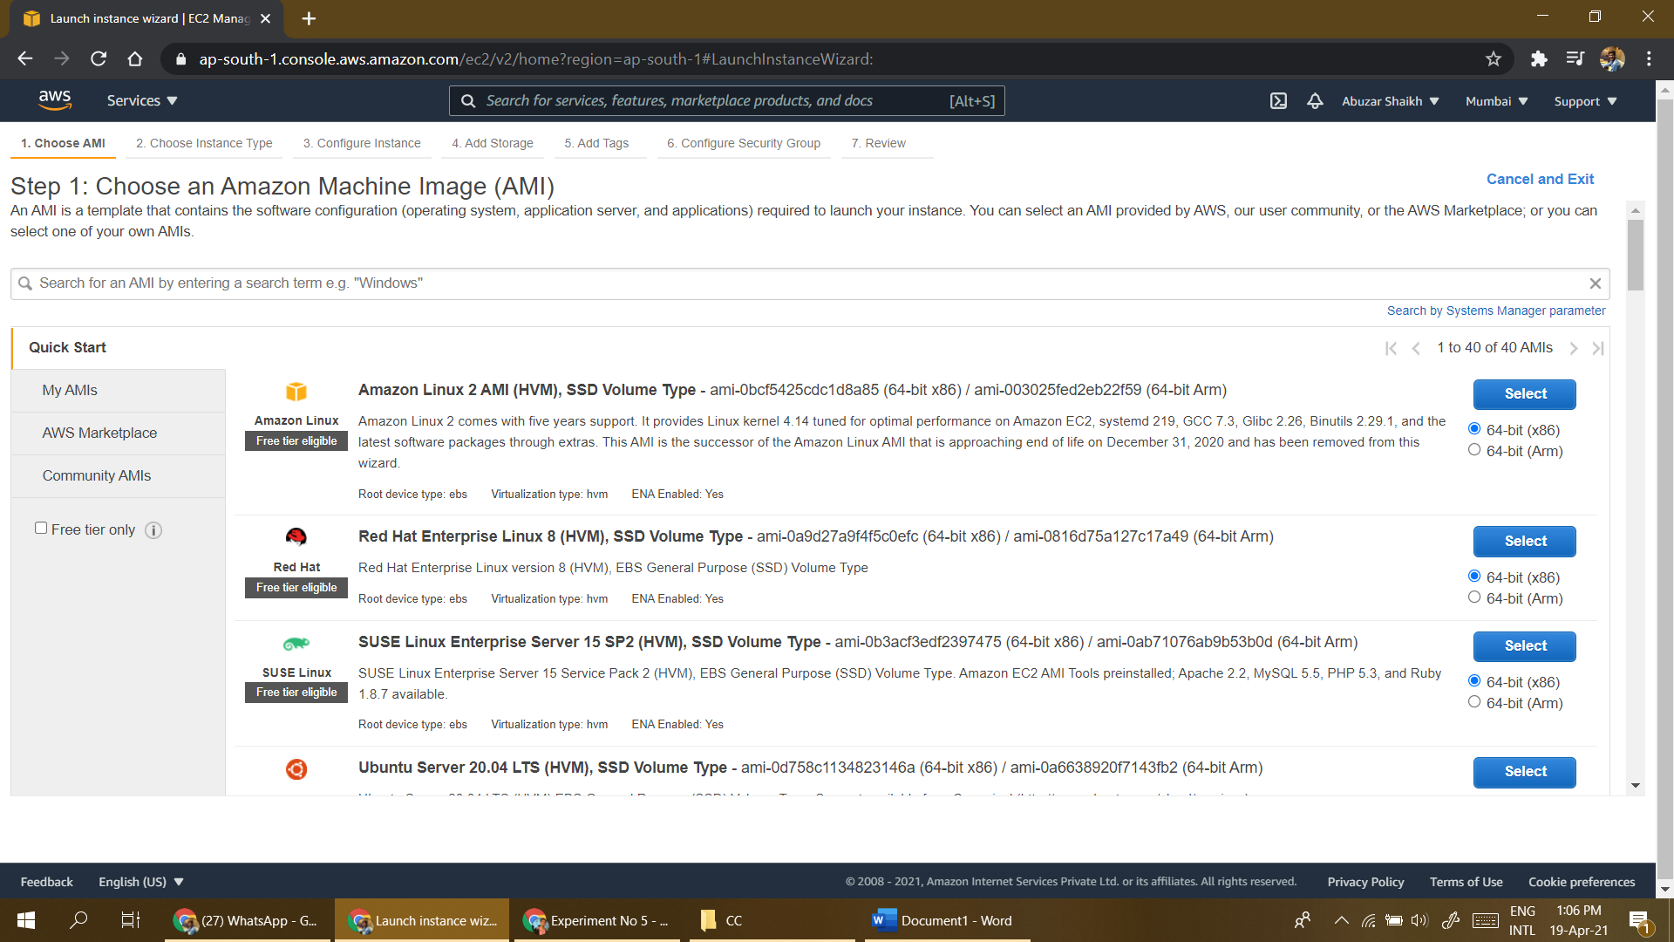

1. Select the operating system type in AMI format. In this example we have selected Windows server instance which is eligible for free tier and click on Next.

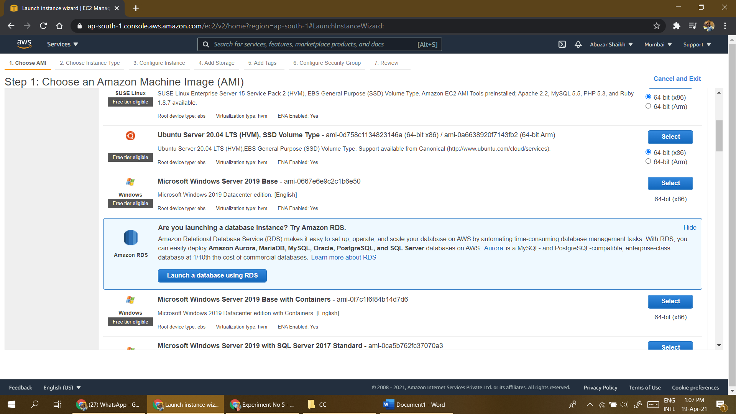

1. Now select the hardware type for Virtual machine. In this example we have selected free tier eligible General-purpose hardware and click on Next.

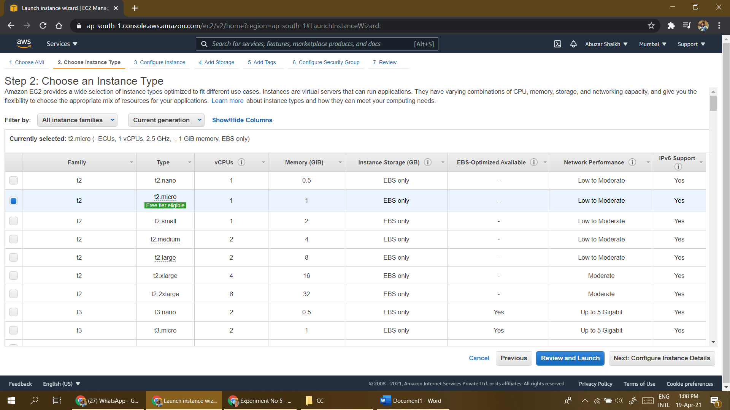

1. Now specify the instance details like Number of instances, networking options like VPC, Subnet or DHCP public IP etc. and click on Next.

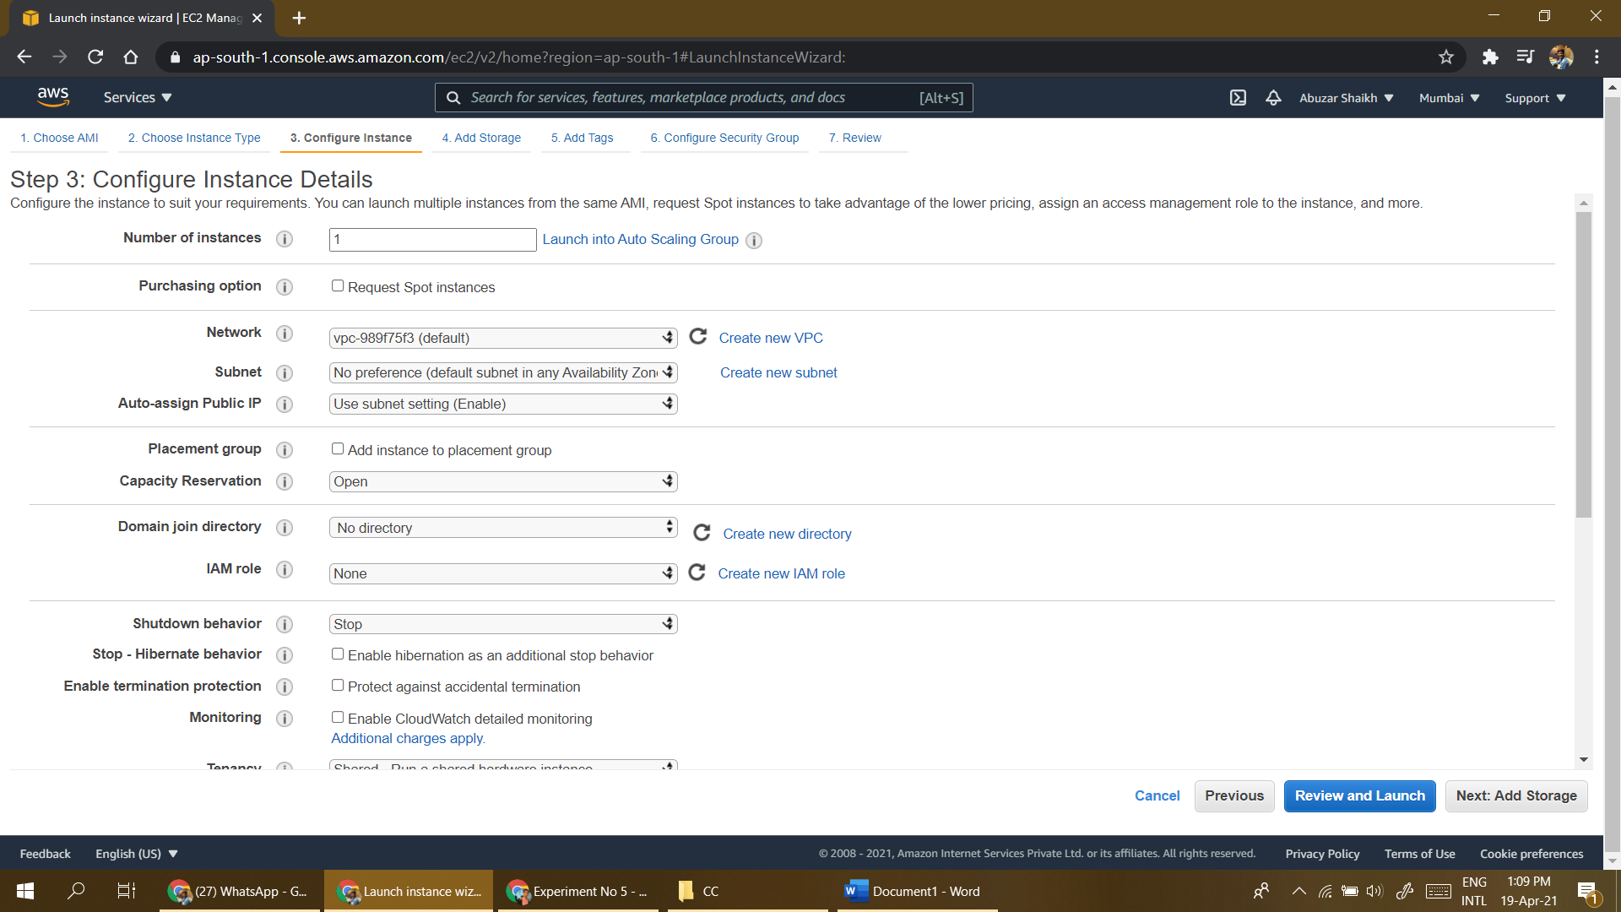

1. Specify the storage space for VM and click on Next. Click on Add tag to specify VM Name and click on Next. Configure security group to provide access to VM using different protocols.In this example we have selected default RDP protocol.

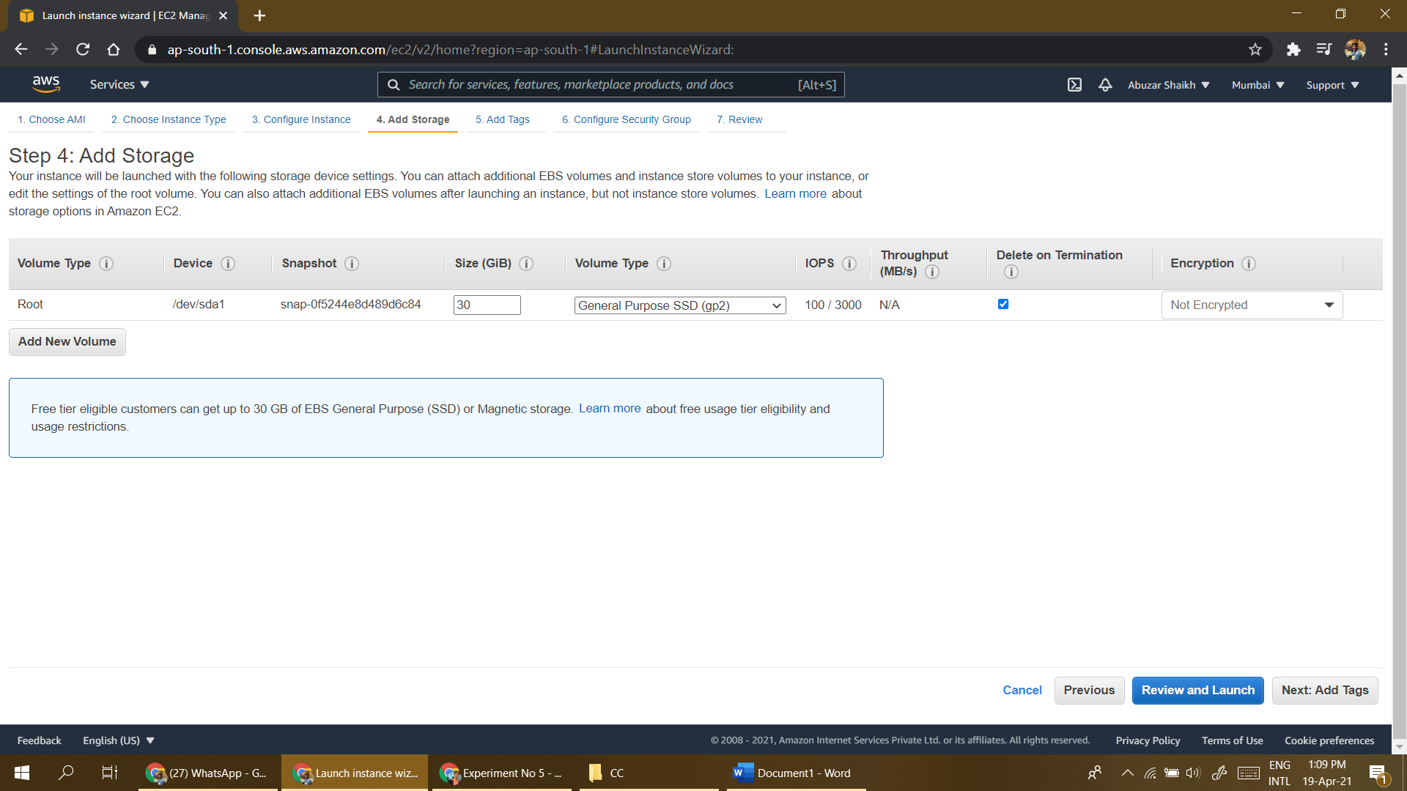

1. Now Review the instance and click on Launch button.

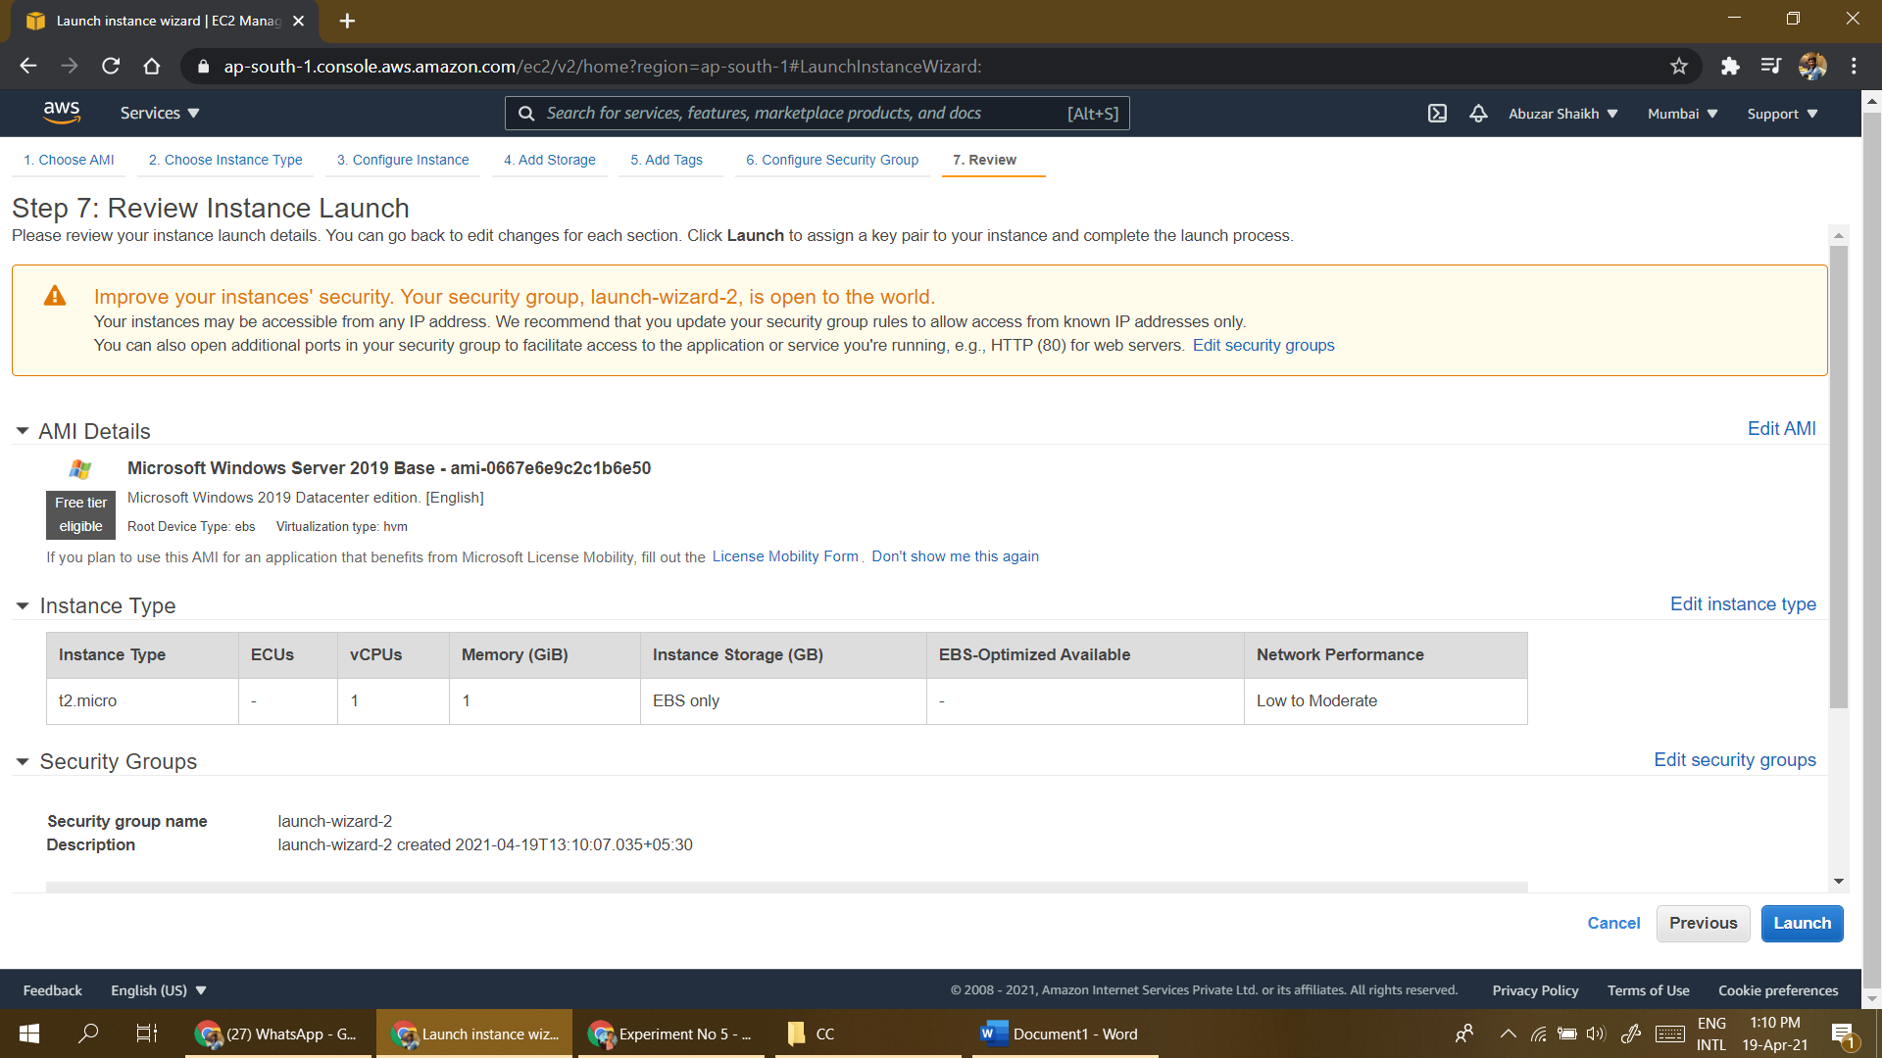

1. Now to secure VM instance, Encrypt it using public key and create a private key pair to decrypt that. Here specify key pair name and download key pair.

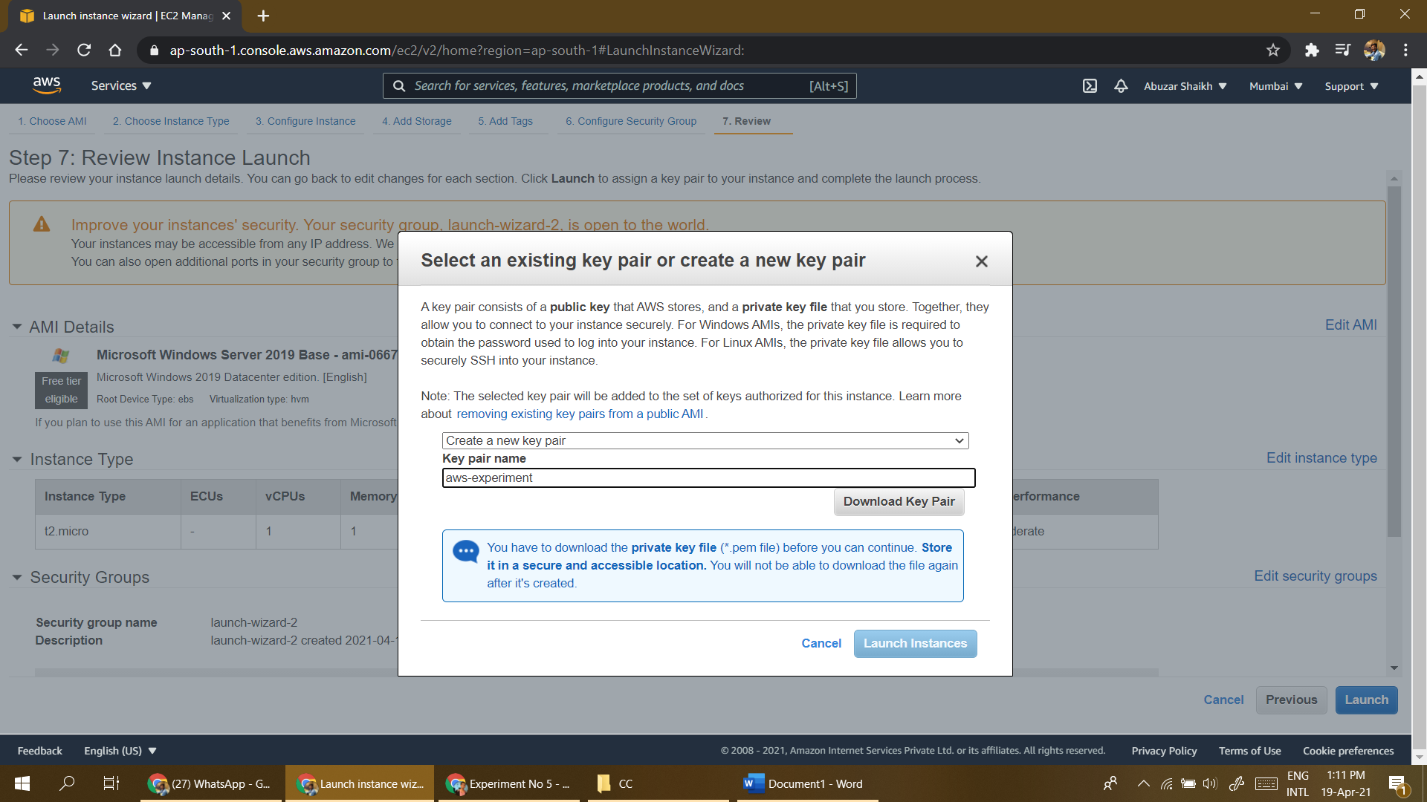

1. Now from summary page click on View instance to see the instance state. After some time you will see the running instance of your VM.

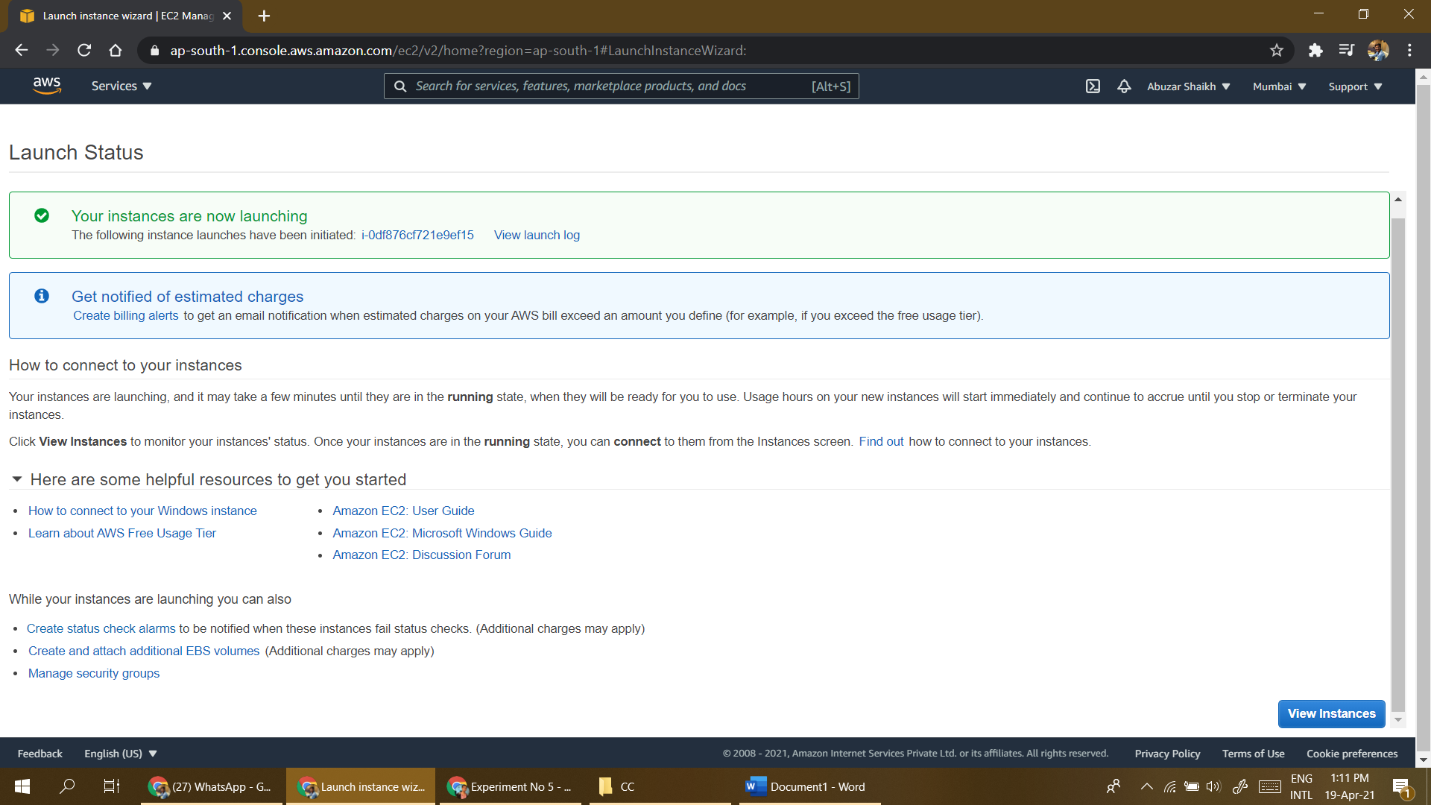

1. Now Click on Connect to get the password for VM to access it over RDP protocol.

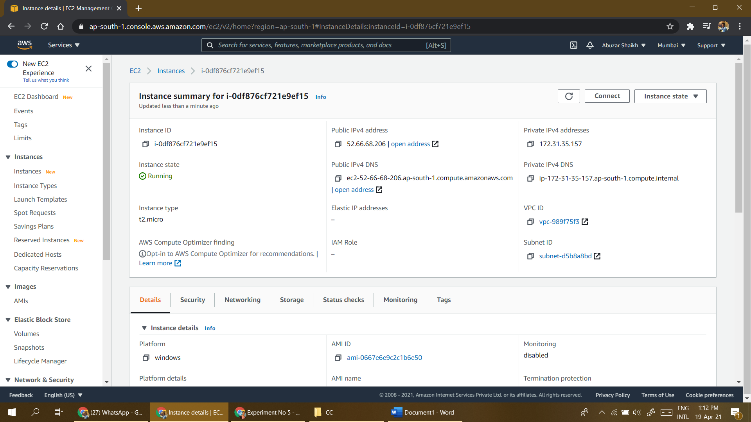

1. Select the downloaded key pair file to decrypt the password.

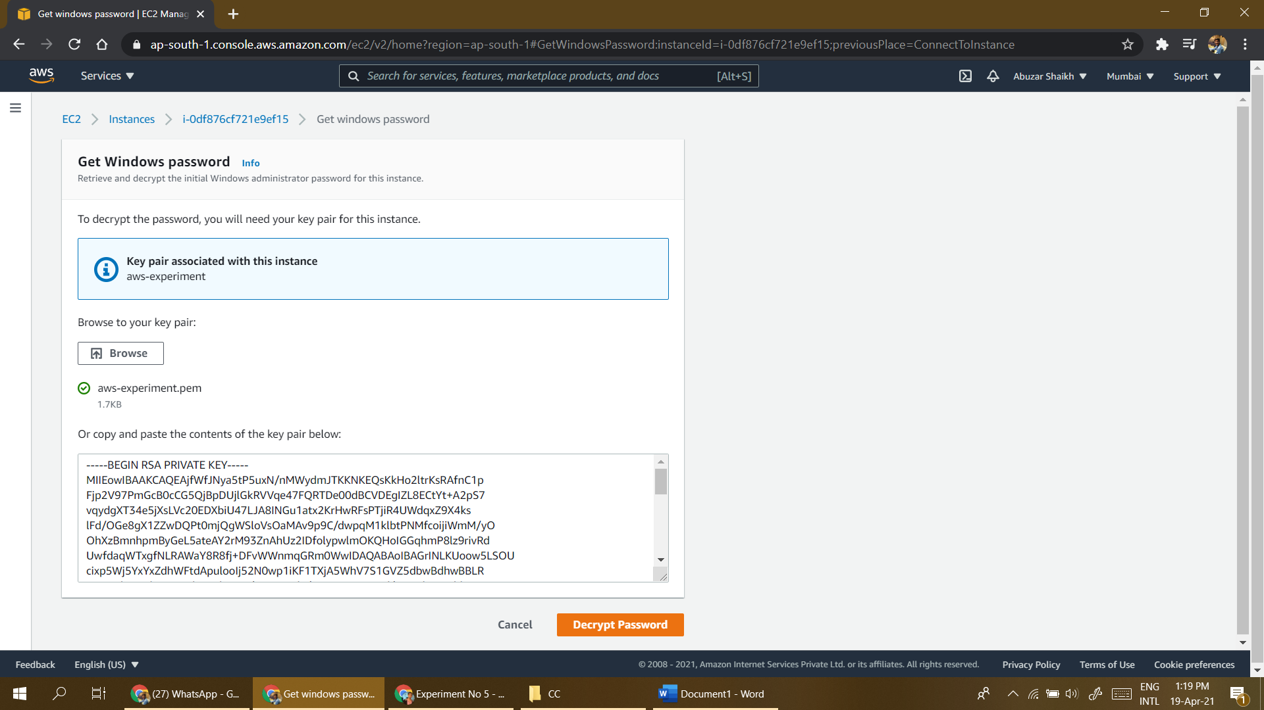

1. Now connect the instance using RDP tool by using IP address/DNS, username and Password decrypted in last step.

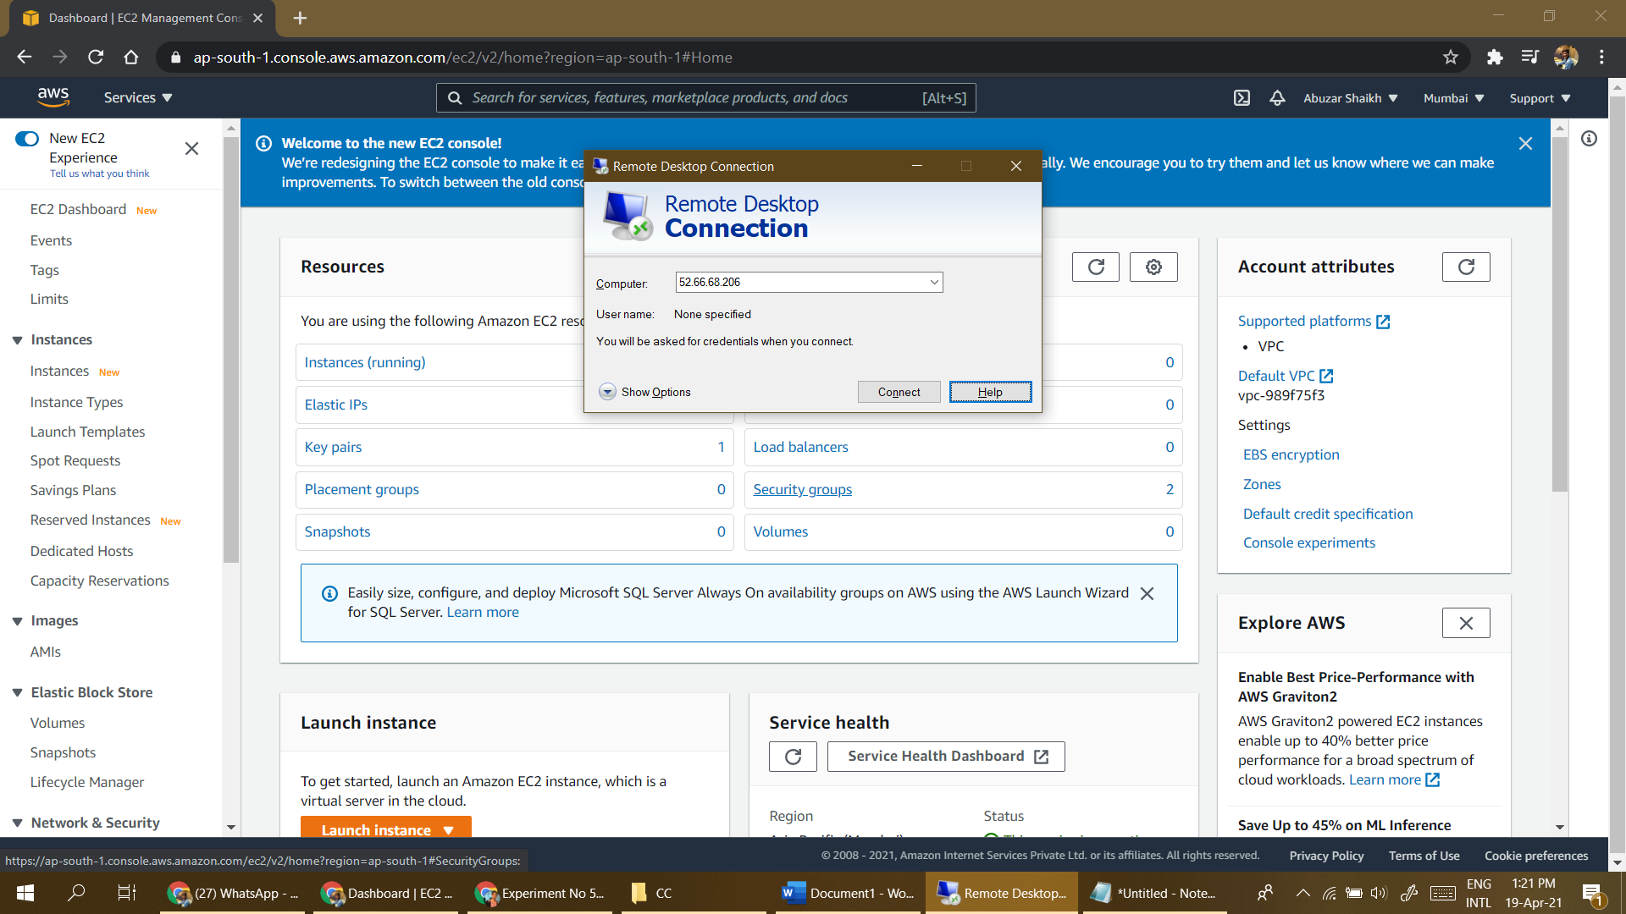

1. Once you click on connect, you will see the running Windows virtual machine as shown below.

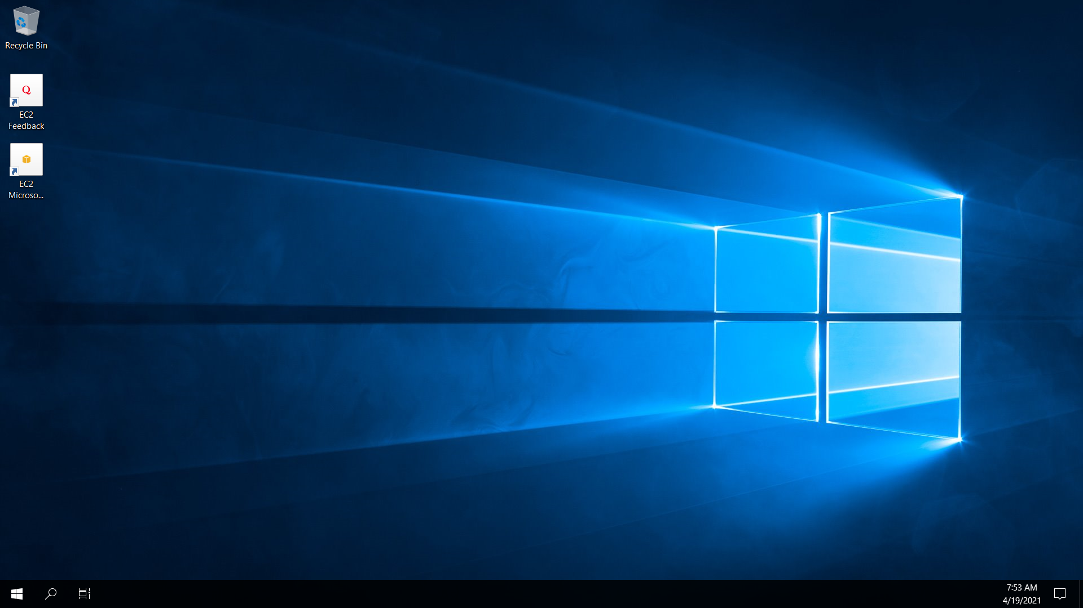

1. You can shut down instance by selecting instance state followed by stop.

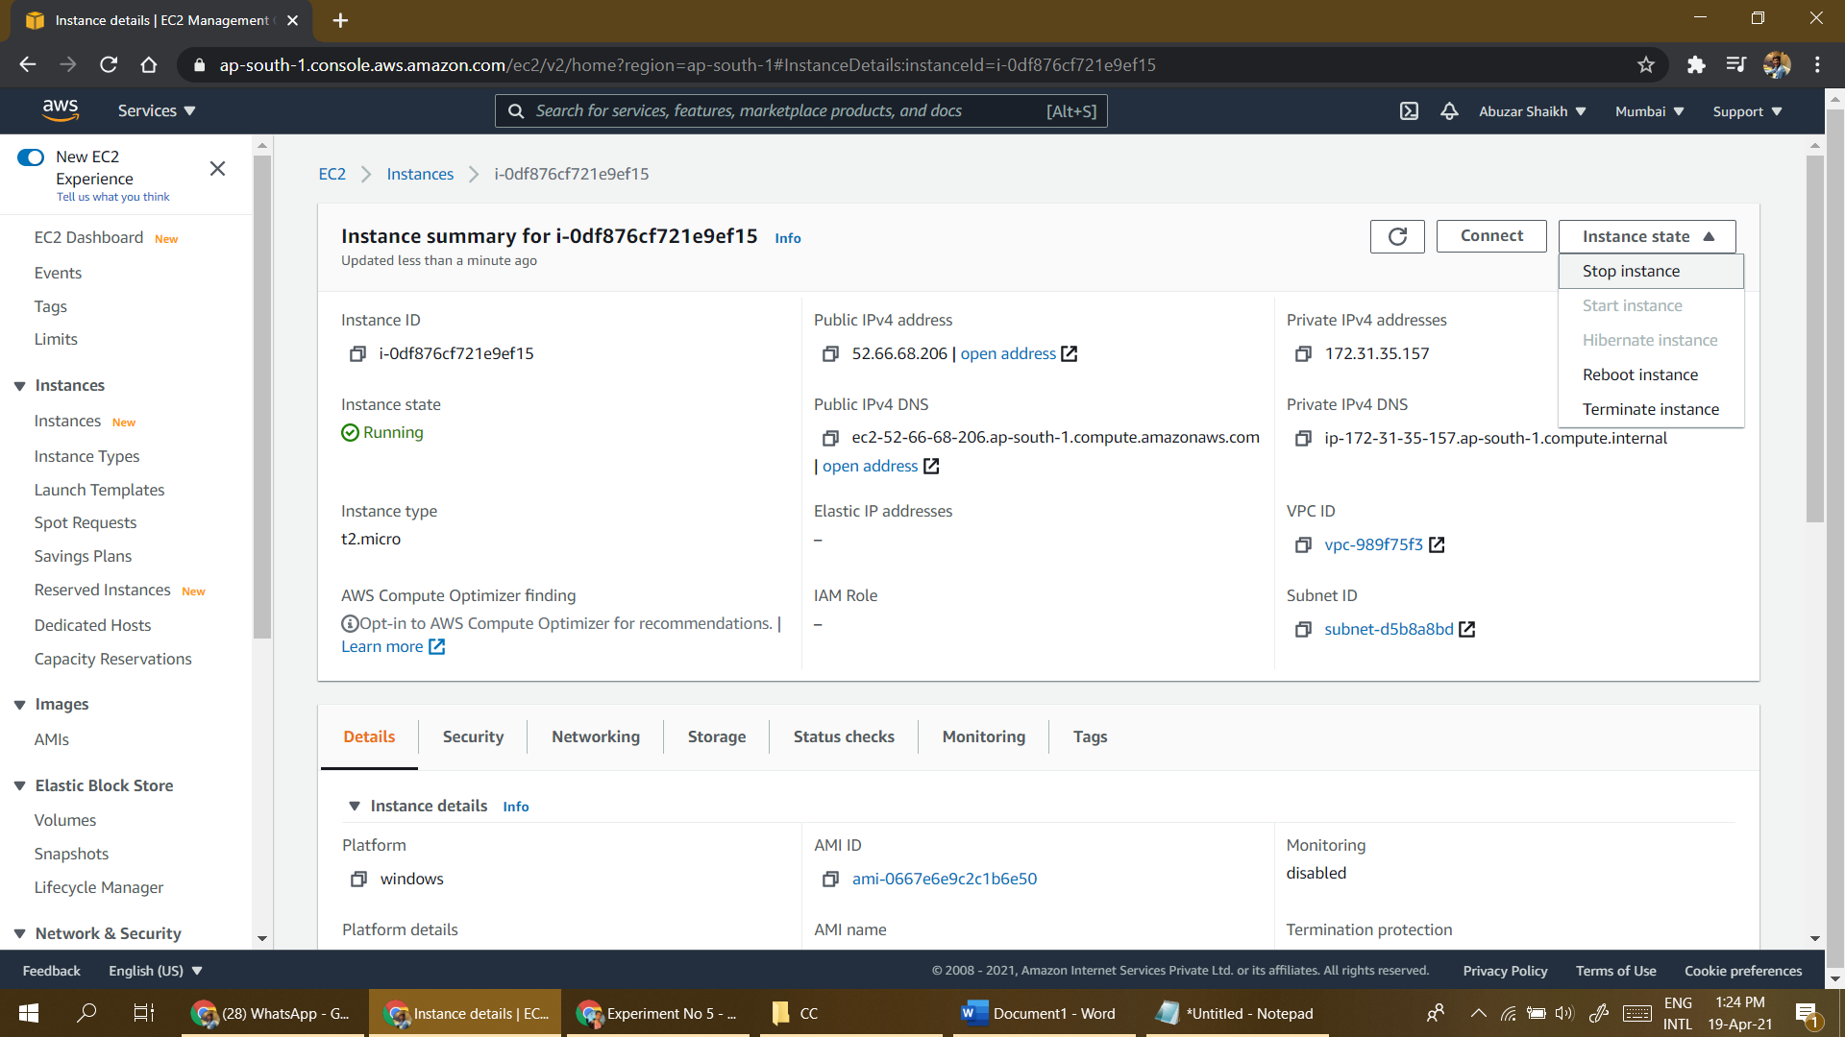

1. You can delete the instance permanently by selecting instance state followed by terminate.

